RBAFC Competition Rules 2020
Offshore

Revised Dec 2019

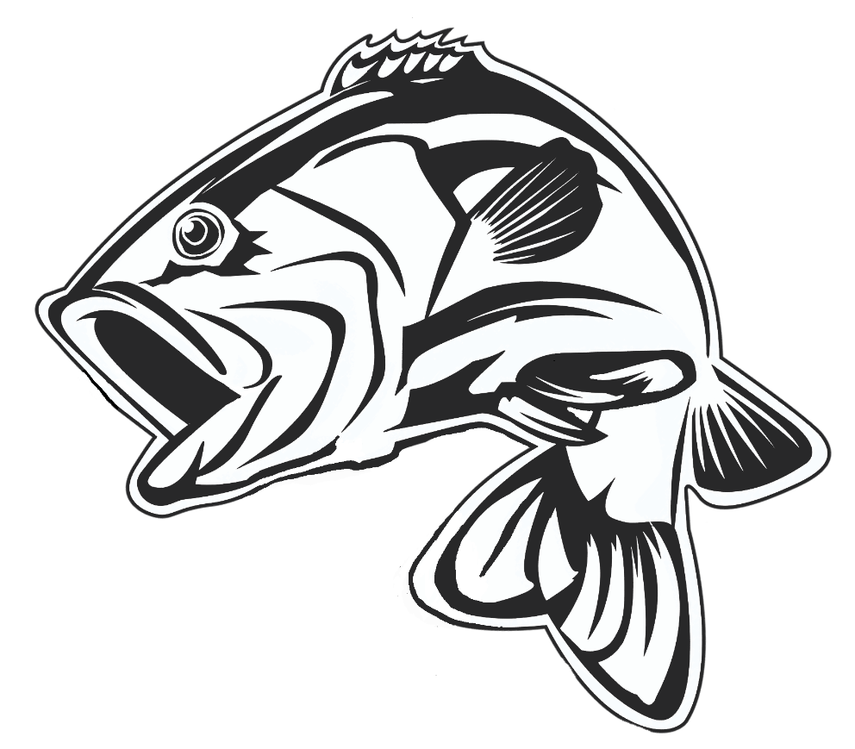

All members/visitors taking part in any club event are expected to conduct
themselves in an honest, respectful manner and promote the objectives of the club.
(1)

Safety Notice: The vessel of a competitor fishing in a club boating event must be fitted with an operational 27 Meg and/or VHF marine radio. All vessels in this event must have a minimum of 2 persons aboard over the age of 16. The wearing of life jackets is mandatory when crossing bars. The operator of the vessel must also comply with minimum safety requirements of the Marine Safety Queensland regulations for offshore boating. Note: A minimum of 3 vessels is required for the event to take place.
Registering to compete:
All members competing must register no later than 7:30pm the Thursday prior to any club fishing event. Registration is made by SMS, phone call or email to the club “competition secretary”. If contact cannot be made with the “competition secretary”, the “competition captain” can be notified.
When an offshore competition and an inshore competition are scheduled for the same period, then the competitor must nominate the category they intend to fish at the time of registration. Competitors are not permitted to fish more than one category in each club event.
However, if an offshore competition is cancelled due to weather concerns, a competitor may then elect to compete in the inshore competition.

Weigh Out (on water) procedure:
All members competing can elect to fish for any period of time during the competition window as per calendar.

Once on the water competitors must notify the offshore captain by radio (27 Meg/channel 94, VHF/channel 72), phone or SMS advising details including time and location of departure. On returning to the ramp competitors must again notify their safe return and sign off.

If contact cannot be made with the offshore captain by radio or phone call, then a text message must be sent to the captain and where possible contact should also be made with any other RBAFC member on the water and request information be relayed onto Captain / Secretary.

Where possible members should stay in contact with one another throughout the event.

Members will utilize the coastguard notification system eg: advising they are about to cross bars and signing off on safe arrival home, the offshore captain is to be advised also.

Offshore Fishing Boundaries
All fishing must take place in Queensland waters.

The offshore fishing boundaries operate on a southern and northern boat launching limit. There is no limit as to how far a vessel may travel from these limits once they are on the water.

No vessel may be launched further south than the Gold Coast Seaway.
No vessel may be launched further North than Mooloolaba.

Weigh In procedure:
All anglers must have their catch at the weigh in by the designated time to be eligible for catch/score to be recorded. A competitor’s catch can be weighed earlier if
- The weigh master agrees
- The competition captain and a second designated person must be present and witness

(2)

If a competitor is unable to attend the weigh in, they may elect another person to weigh in their catch. For this to be permitted, the competition captain or competition secretary must be notified at the time of registration and a reasonable explanation provided. NOTE: Feeling tired is not a valid reason

Registered competitors who do not weigh in must declare “NO FISH” to be recorded as having participated in the event.

All fish presented for weigh in must be weighed whole and in good condition. Fish mutilated or disfigured in any way will not be accepted.

Anglers will be asked to present their catch in the following order:
- Juniors
- Ladies
- Men

Fish will be placed in the provided basket prior to approaching the scales. A short period will then be provided for other competitors to inspect the fish presented.

If an angler has committed to help with a RBAFC pub raffle on the same day of the weigh in, then the weigh in shall be delayed until the pub raffle is complete and that angler can attend.

Penalties (Strictly Enforced)
The competition conditions and rules must be adhered to during competition events. If these rules are found to have been breached the following will apply:
- A 25 point penalty per fish will be imposed on any angler who presents to the weigh master any fish which are undersized. The penalty points will be deducted from the anglers accrued completion points total.
- Should 4 or more undersized fish be presented, the total days catch will be disqualified from the event and 100 points deducted from the angler’s competition points.
- All fish are deemed presented to the weigh master when brought to the weigh in area.
- The weigh master will determine and declare any under size fish presented to them
- Any disputes arising at the weigh in will be adjudicated by the competition secretary or captain. Their decision will be final in all matters.
- Any competitor found to be discarding/dumping or failing to care for their catch in a manner that would render the catch inedible will be disqualified from the trip. Their total days catch will be disqualified from the event and 100 points deducted from the angler’s competition points. Any prizes awarded for the trip prior to the offence must be returned to the competition captain. Any reports of fish mishandling/dumping will be adjudicated by the competition secretary or captain. Their decision will be final in all matters. Any dispute must be raised with the competition captain within 24 hours of the weigh in.
- Any club member giving or receiving fish from another member or visitor for his/her own personal gain at the weigh in, shall be disqualified from the club for life.

Visitors/Guests fishing during club events:
Any visitors or guests fishing during an event must declare their catch at the time of weigh in and are expected to follow the same rules as club members. Any visitor taking part in 3 or more club events is expected to lodge an application for membership with the club.

Alterations to club events by captain:
The captain or his delegate for an event may cancel an event if in their opinion changing weather conditions pose a threat to competitors’ safety. The decision will be made as early as practical and

(3)

all competitors will be notified by via whatever communication means are available to the captain. The captains’ decision in these matters is final and no appeals shall be entered into.

Competition Rules (from club constitution)
Club competitions shall be subject to the following general regulations:
- All fish must be weighed in whole.
- If the angler wishes to gill and gut their catch, the fish will be allocated 10% of their gross weight.
- Crabs shall not be weighed in.
- Competitors can use 3 rods or hand lines in any competition with not more than two hooks on each line. A flight is to be considered as 1 hook.
- Any fish weighed in by a competitor must have been caught and reeled in by the competitor.
- Fish shall be washed free of sand etc before weighing in and officials have the power to order fish be cleaned of sand and other foreign matter.
- No Bill fish, Marlin or protected species are to be weighed in.
- Any member or visitor attending a trip and who, in the opinion of a quorum, is not in possession of his/her faculties will not be permitted to fish or participate at that outing.
He/she shall not be recorded in the books of the Club as having attended that outing.

Open, ladies and juniors’ events:
Three offshore competitions will be fished as follows
- Combined open competition
- Ladies competition
- Junior competition (juniors must be under 16yrs of age as of the RBAFC sign on day)

Trophies and awards:
Should a tie eventuate at the end of the fishing year, the trophy will be awarded to the angler with the least fish caught during that year. This will acknowledge those members who caught quality fish.

Trophies will only be awarded to financial RBAFC members that meet the minimum 5-point system qualifications. A visitor’s recorded catch will be eligible for a trophy if they later become a financial member and meet the same minimum 5-point system qualifications.

Minimum Qualification for Trophies (5 Point System)
Ladies and Juniors have no minimum qualification criteria. Senior men must accrue a minimum of 5 points to qualify for any trophy. Points may be obtained as follows:

Inshore Event (including artificial Bait event) (1) point per event
Offshore Events (1) point per event
Beach Events (1) point per event
Raffle Selling (1) point per each raffle event attended
Boat Skipper on Ladies / Junior Events (1) point per event
Club Committee Member (1) point per year

Rookie Trophy:
Eligible rookies will score points towards Rookie of the Year. To qualify as a rookie the competitor must:
- Be in their first 3 years at the club
- Not have won the rookie category previously
- Not have exceeded 500 points in one season previously

(4)

Club Champion Trophy
To qualify for the Club Champion Trophy the competitors must compete in at least two competition categories from the following: Inshore, Offshore, Beach.
The Club Champion Trophy will be awarded to the competitor with the most points accrued from the following categories: Inshore, Offshore, Beach, Artificial Bait Day.

Heaviest Fish Species – Offshore (Open to Seniors, Ladies & Juniors)
A trophy will be awarded at the end of year for the heaviest of the following species.
Tuna, Snapper, Pearl Perch, Moses Perch, Maori Cod, Parrot, Grass Emperor, Spangled Emperor, Amberjack, Mackeral, Cobia, Kingfish and Mahi Mahi.

Weight and measures – Offshore (Revised Dec 2019)

Offshore
SPECIES | BAG LIMIT | MINIMUM SIZE | BONUS WEIGHT
Pearl Perch | 4 | 38cm | 2kg
Moses Perch | 5 | 30cm | .8kg
Mackeral - Spotted & School | 5 | 60cm | 3kg
Mackeral - Spanish | 3 | 75cm | 10kg
Cobia | 2 | 75cm | 10kg
Parrot | 5 | 30cm | 2kg
Squire/Snapper | 4 | 40cm - no more than 1 over 70 cm | 4kg
Spangled Emperor | 5 | 45cm | 5kg
Grass Emperor | 5 | 30cm | 1.5kg
Kingfish - Yellowtail | 2 | 60cm | 10kg
Maori Cod | 2 | 45cm | 2kg
Amberjack | 2 | 50cm | 10kg
Mahi Mahi | 5 | 50cm | 5kg
Tuna | 5 | 35cm | 10Kg
All other species must be a minimum of 35cm (or longer as per fisheries regulations)
There will be a bag limit of 5 fish for all other species and no bag points will apply.
Fish such as gar, pike, scad and all bait fish including mullet are excluded from weigh ins.
Sergent Baker, Grinner, Long Tom, Iodine Bream, Ghost fish are also excluded from weigh ins
Only 2 cod (excluding Maori) will be eligible for weight points per trip. No Bill fish, Marlin or protected species are to be weighed in.

Points System:
1 point is awarded per 100gms of fish
10 points are awarded per species
1 point is awarded per fish
Bag limits will attract a bonus of 20 points per species listed above
Maximum points for any one fish is 150 points
Maximum points for any one species is 250 points
Heaviest off the designated event species will be awarded an extra 50 bonus points

(5)

Designated species:
On offshore trips the designated species will be chosen as follows :
Prior to the commencement of the weigh in a list of species caught shall be placed into a hat on individual tickets. The person having caught the heaviest of the species drawn from the hat will be declared the species winner. The winner will attract an extra 50 bonus points. In the event that there is more than one fish of the same weight, the compeitior that weighs in first will be the winner.

Handicaps:
The trip winner will be handicapped 20 points per trip win which will accrue to the end of the fishing year but will not affect the total points for club trophies. Ladies and Juniors will attract a 10 point handicap under the same circumstances.

Points Tie Protocol
Should a point’s tie eventuate at the end of a weigh in, the winner will be the competitor with the least number of fish caught. This will acknowledge those members who caught quality fish. If they both have the same number of fish it will be awarded to the competitor that weighed in first.
New member point’s incentive (Established 2019):
A new RBAFC member in the first year of their membership (must not have been a member of the club previously) will be classed as a NEW MEMBER. Existing RBAFC members can earn 20 bonus points for taking a NEW MEMBER fishing. For an existing member to qualify for the 20 points the following criteria must be met:
- They take a new member/s fishing with them on any club competition trip.
- The NEW MEMBER must catch an eligible fish in accordance with the RBAFC rules. That fish must be weighed in and recorded.
An existing member can only earn the 20 points once for per new member. This is to encourage existing members to take new members and welcome them into the club.

Junior member participation incentive (Established 2019):
Each junior angler that fishes in a club event and weighs in at least one fish (in accordance with the RBAFC rules) will receive a ‘lucky dip’ prize.
The junior angler with the most points overall for that trip will receive a second ‘lucky dip’ prize.

Late membership renewal disqualification (Established 2019):
Any person having been a financial member the previous year and has not renewed their membership for the current year, will not be eligible to weigh fish in for a club competition until such time as they pay their annual member ship for the year. The cut-off date for membership renewal is the last day of February.

Offshore Backup Trips
An offshore backup trip can be requested by any competitor that has participated in an offshore competition for the current year. The trip can only take place if approved by a vote. Only anglers that have fished a previous offshore trip that year may cast a vote. The vote must be carried by more than 50%. In the event of a tie, the offshore captain will have a second vote. A minimum of 3 vessels is required for the event to take place.

